

**NAME:-SYED.MANSOOR BASHA**

**REG.NO:-192111385**

**COURSE.CODE:-CSA1190**

**COURSE.NAME:-OBJECT ORIENTED ANALYSIS AND DESIGN**

**EXPERIMENT-11:-**

**AIM:-** To implement UML diagrams for Conference management system.

**DESIGNS:-**

**1.USE-CASE DIAGRAM:-**

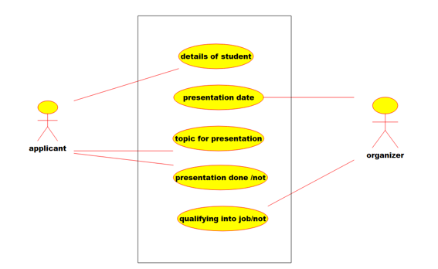

**2.DEPLOYMENT DIAGRAM:-**

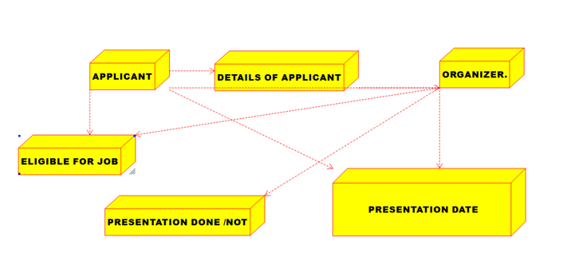

**3.PACKAGE DIAGRAM:-**

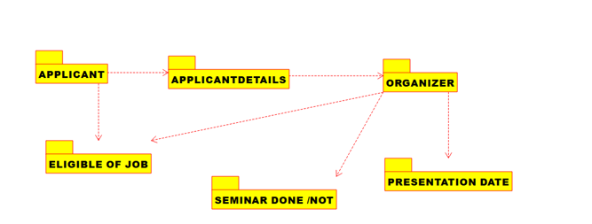

**RESULT:-** The uml diagrams of program was executed successfully by using umbrello.

**EXPERIMENT-12:-**

**AIM:-** To implement UML diagrams for Foreign Trading System.

**DESIGNS:-**

**1.ACTIVITY DIAGRAM:-**

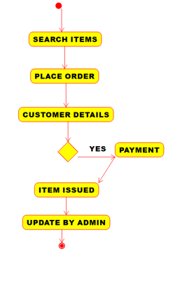

**2.SEQUENCE DIAGRAM:-**

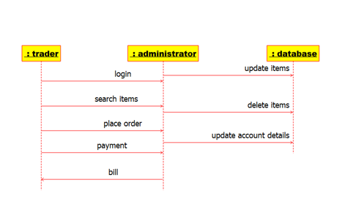

**3.COMPONENT DIAGRAM:-**

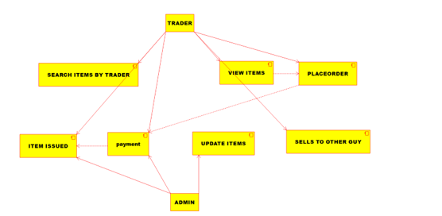

**RESULT:-** The uml diagrams of program was executed successfully by using umbrello.

**EXPERIMENT-13:-**

**AIM**:-To implement UML diagrams for BPO Management System.

**DESIGNS:-**

**1.ACTIVITY DIAGRAM:-**

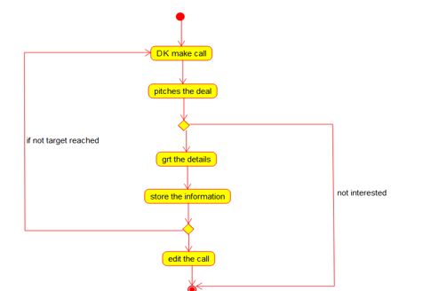

**2.STATE-CHART DIAGRAM:-**

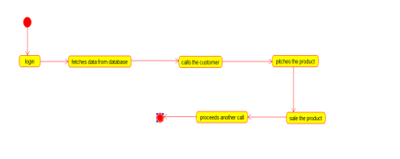

**3.CLASS DIAGRAM:-**

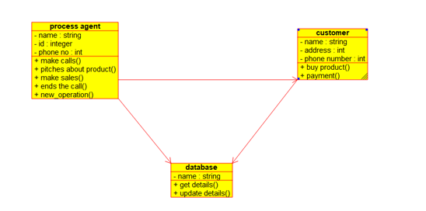

**RESULT:-** The uml diagrams of program was executed successfully by using umbrello.

**EXPERIMENT-14:-**

**AIM:-** To implement UML diagrams for E-Commerce Registration.

**DESIGNS:-**

**1.ACTIVITY DIAGRAM:-**

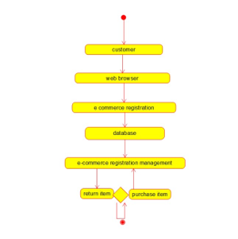

**2.SEQUENCE DIAGRAM:-**

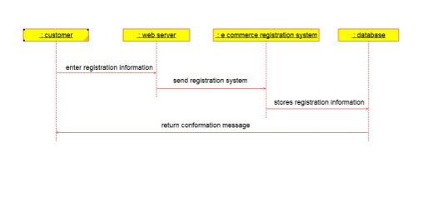

**3.PACKAGE DIAGRAM:-**

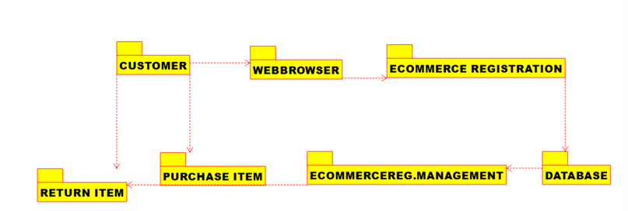

**RESULT:-** The uml diagrams of program was executed successfully by using umbrello.

**EXPERIMENT-15:-**

**AIM:-** To implement UML diagrams for Blood Bank Registration System.

**DESIGNS:-**

**1.USE-CASE DIAGRAM:-**

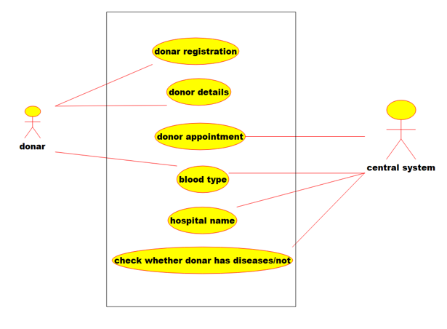

**2.COLLABORATION DIAGRAM:-**

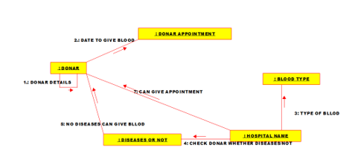

**3.STATE-CHART DIAGRAM:-**

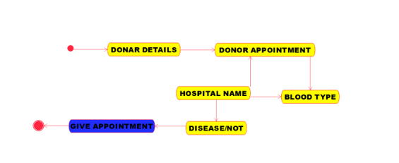

**RESULT:-** The uml diagrams of program was executed successfully by using umbrello.

**EXPERIMENT-16:-**

**AIM:-** To implement UML diagrams for Online Internship Registration System.

DESIGNS:-

**1.COMPONENT DIAGRAM:-**

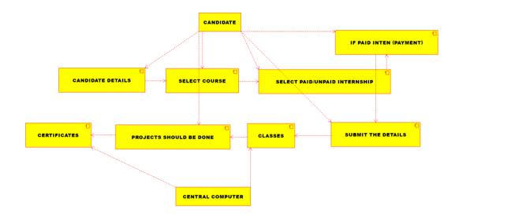

**2.COMPONENT DIAGRAM:-**

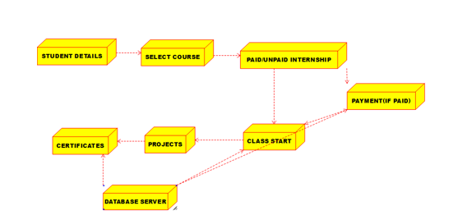

**3.ACTIVITY DIAGRAM:-**

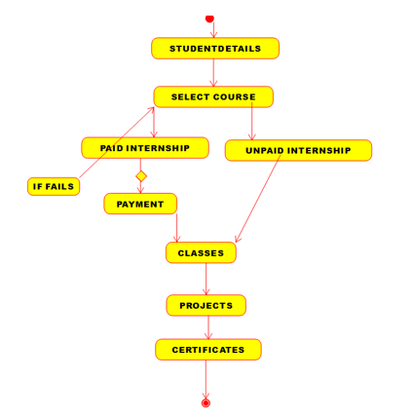

**RESULT:-** The uml diagrams of program was executed successfully by using umbrello.

**EXPERIMENT-17:-**

**AIM:-** To implement UML diagrams for Vehicle Registration Number Registering System.

**DESIGNS:-**

**1.CLASS DIAGRAM:-**

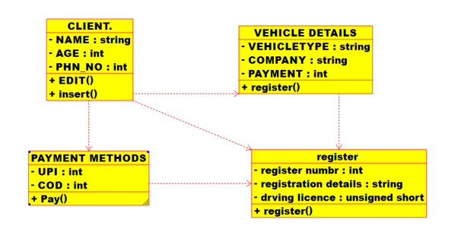

**2.SEQUENCE DIAGRAM:-**

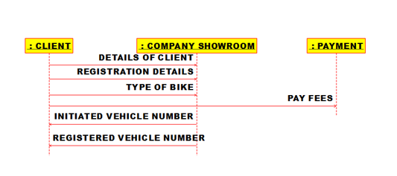

**3.PACKAGE DIAGRAM:-**

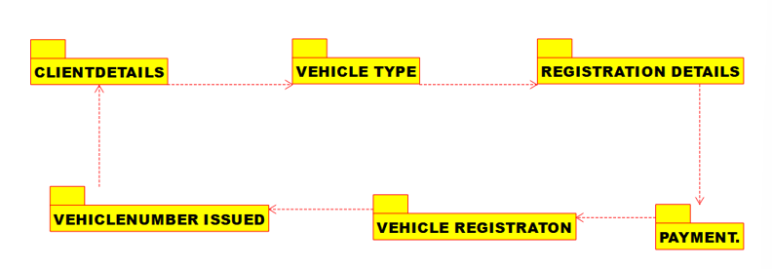

**RESULT:-** The uml diagrams of program was executed successfully by using umbrello.

**EXPERIMENT-18:-**

**AIM:-** To implement UML diagrams for FOOD ORDERING System.

**DESIGNS:-**

**1.USE-CASE DIAGRAM:-**

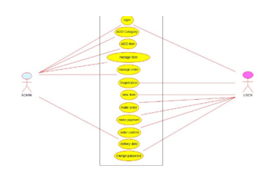

**2.CLASS DIAGRAM:-**

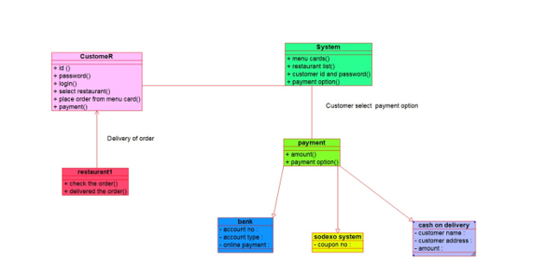

**3.COLLABORATION DIAGRAM:-**

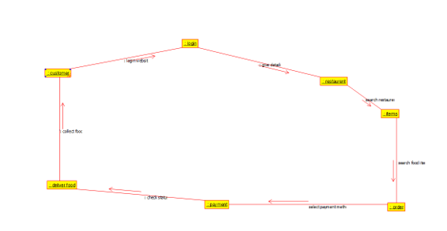

**RESULT:-** The uml diagrams of program was executed successfully by using umbrello.

**EXPERIMENT-19:-**

**AIM:-** To draw the UML diagrams for food ordering system using umbrello.

**DESIGNS:-**

**USE-CASE DIAGRAM:-**

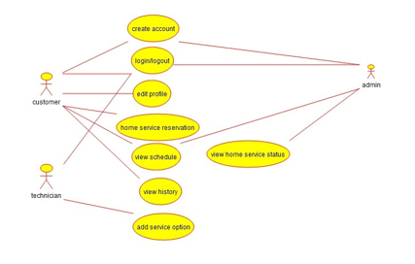

**COMPONENT DIAGRAM:-**

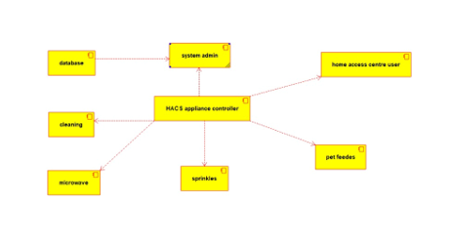

**DEPLOYMENT DIAGRAM:-**

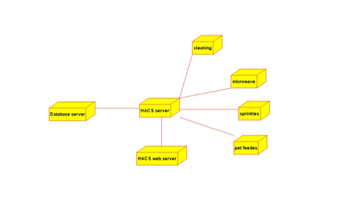

**RESULT:-** The uml diagrams of program was executed successfully by using umbrello.

**EXPERIMENT-20:-**

**AIM:-** To draw the UML diagrams for food ordering system using umbrello.

**DESIGNS:-**

**ACTIVITY DIAGRAM:-**

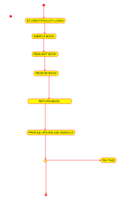

**COMPONENT DIAGRAM:-**

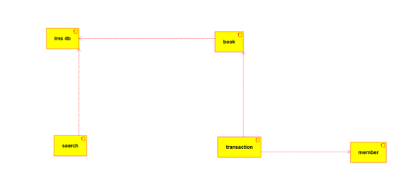

**DEPLOYMENT DIAGRAM:-**

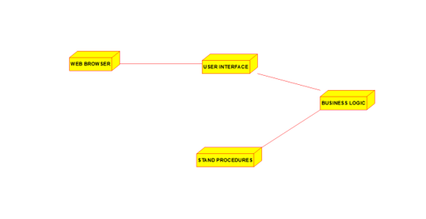

**RESULT:-** The uml diagrams of program was executed successfully by using umbrello.